786
Name: Muhammad Sherjeel Akhtar
Roll No: 20p-0101
Subject: Numerical Computing
Assignment No: 02
Submitted To Respect Sir: Muhammad Nauman
Section: 5A

.
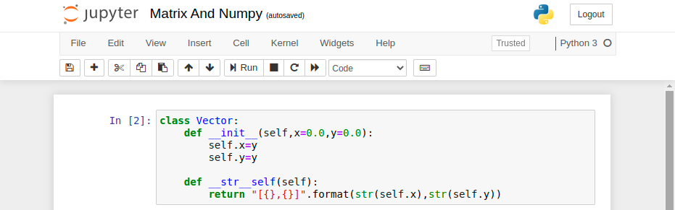
.
.
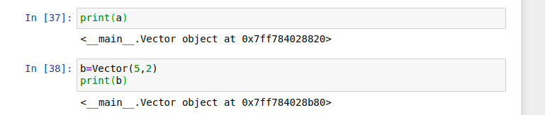
.
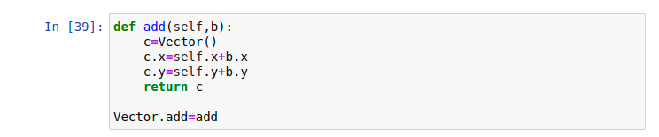
.
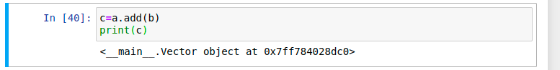
.
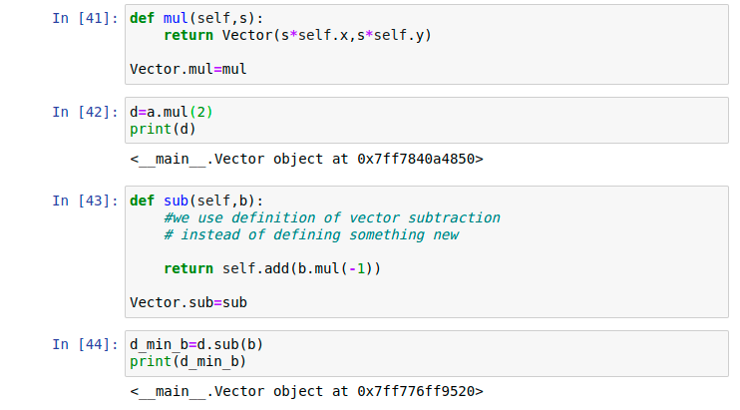
.
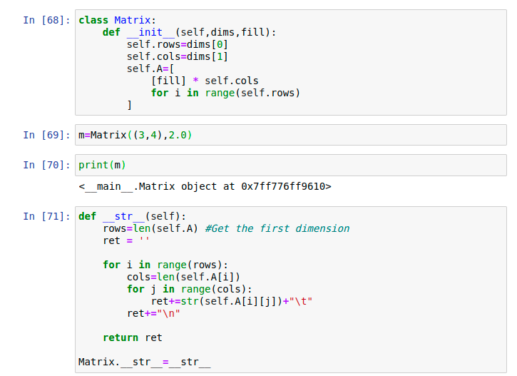
.
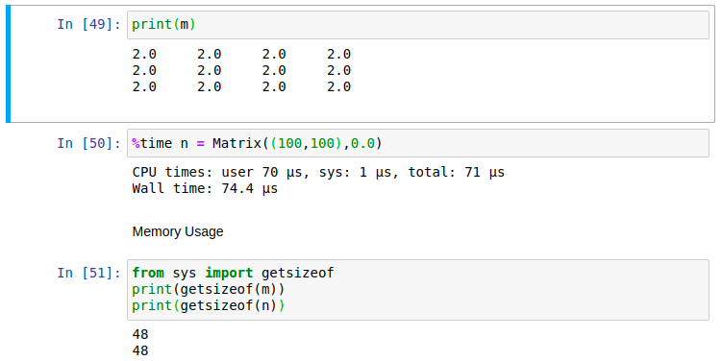
.
.
I was getting the error for PIP. This can be solved by simply typing the following command in the terminal:
“sudo apt install python3-pip”
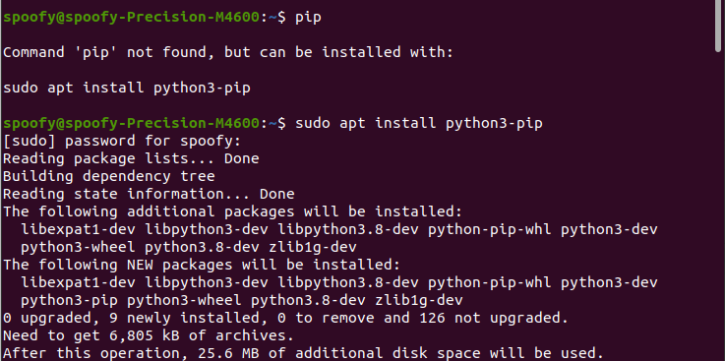
.
After installing pip, run the “!pip install pympler” in the notebook. It will work fine.
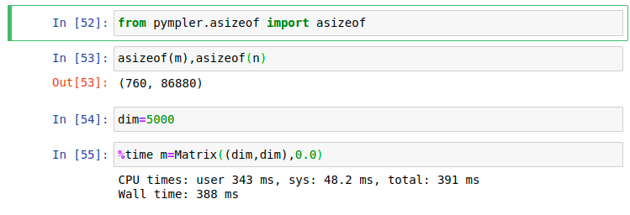
.
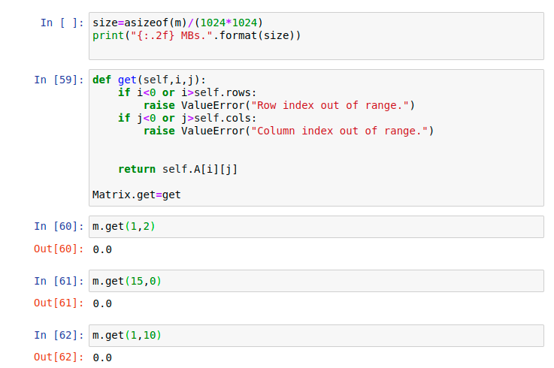
.
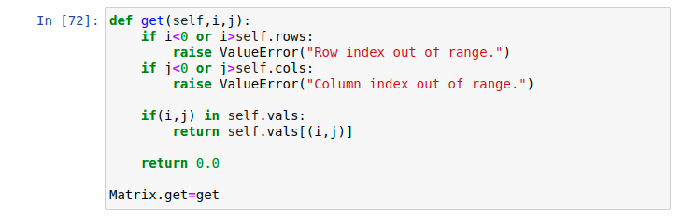
.

Sparse Method:
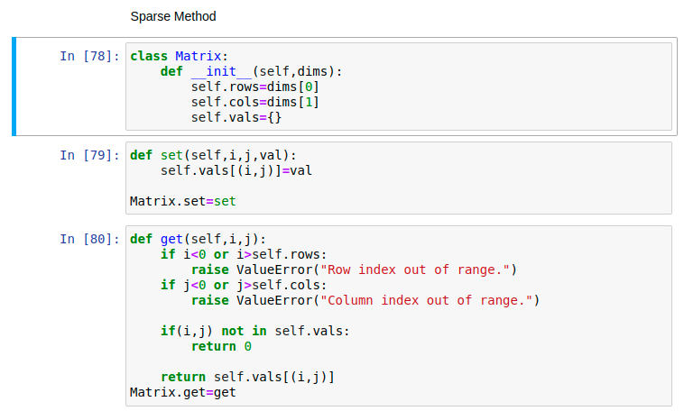
.
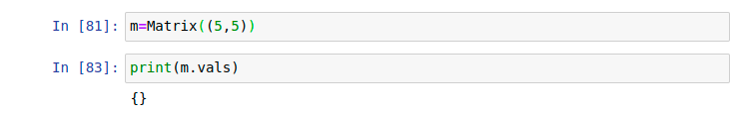
.
.
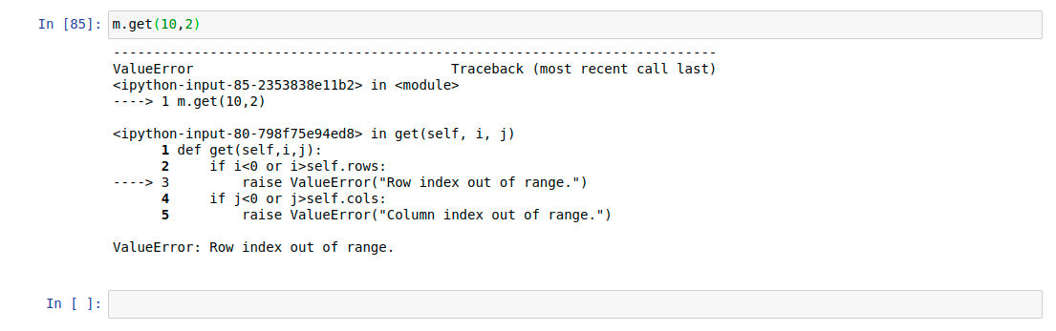
.

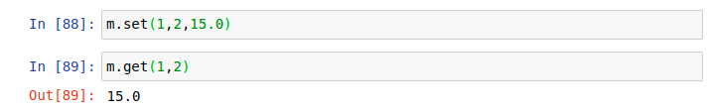
.
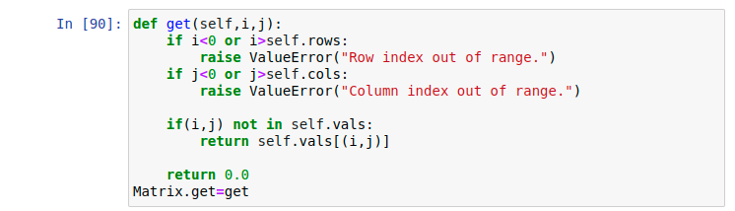
.
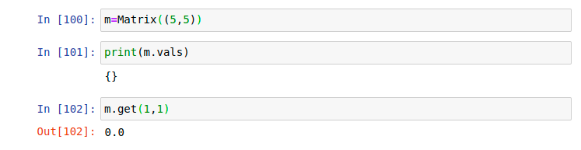
.
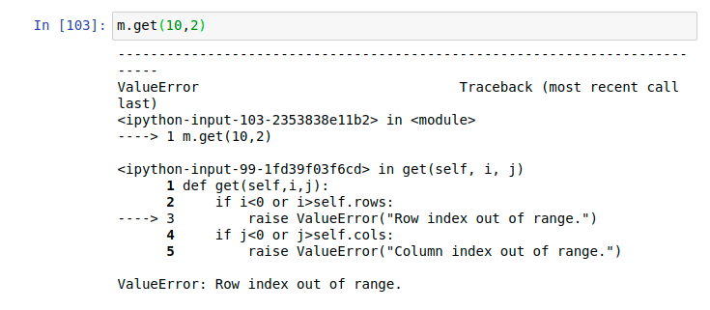
.

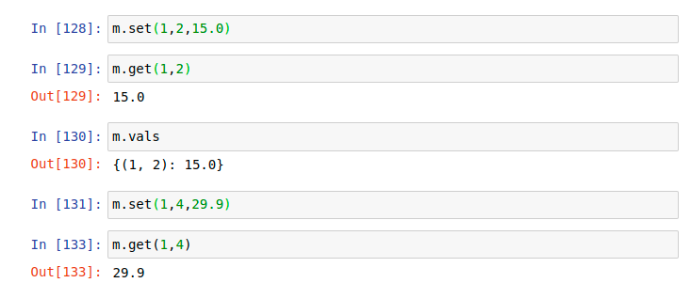
.
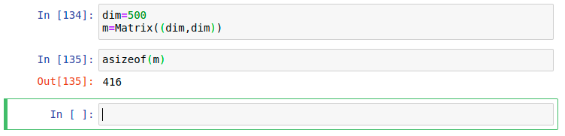
.
.
This command gave some error to me, therefore I installed the “matplotlib” through the terminal.
Use the following command for this purpose:
“pip install matplotlib”
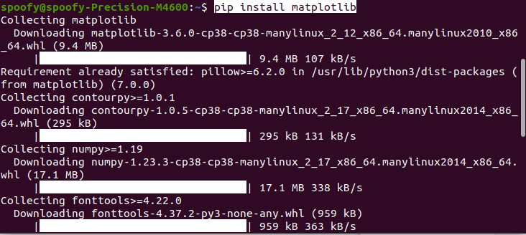
.
Now these both executed successfully.
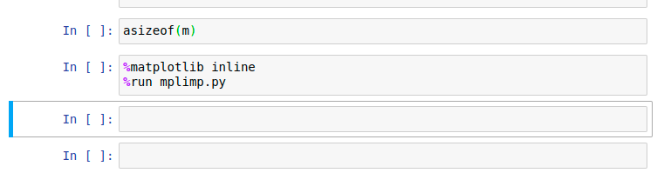
.
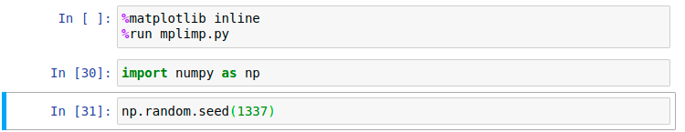
.
Basics Of Matrices:
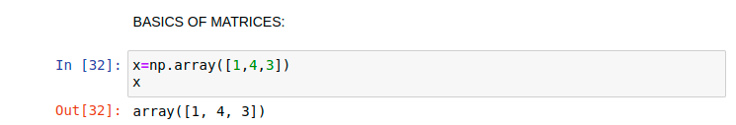
.
.
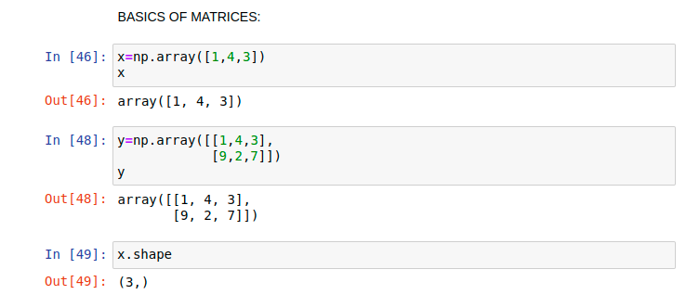
.

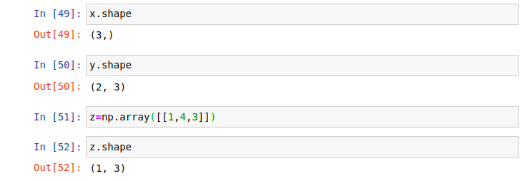
.
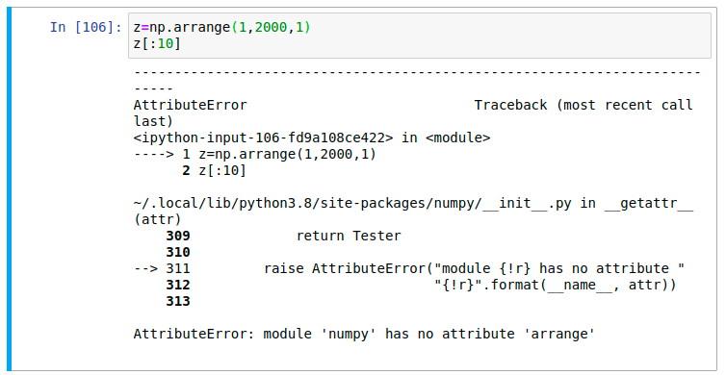
.
There is also this thing that this keyword is ‘np.arange’ not ‘np.arrange’.
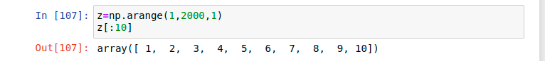
.
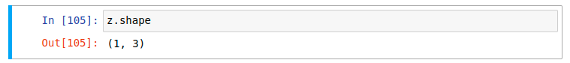
.
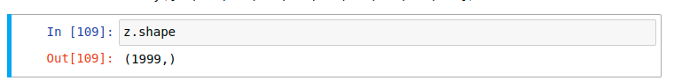
.
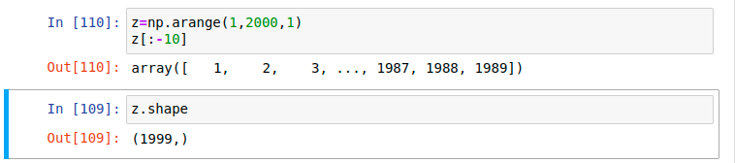
.
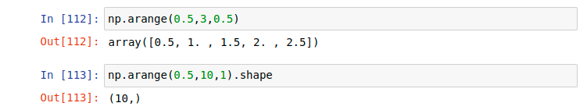
.
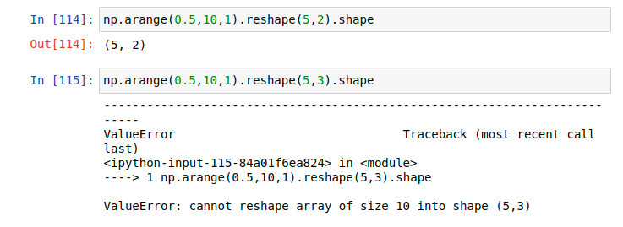
.
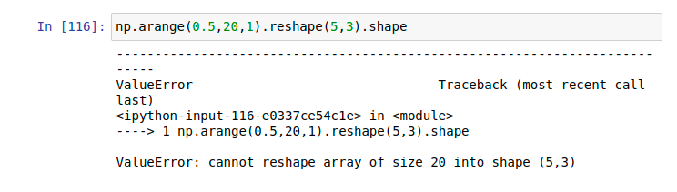
.

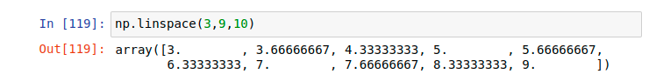
.
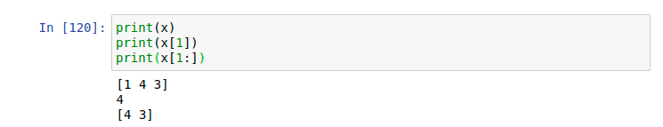
.
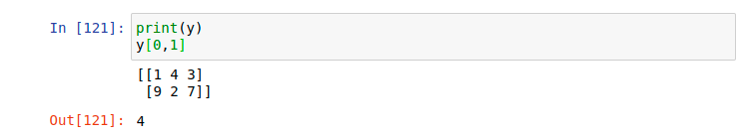
.
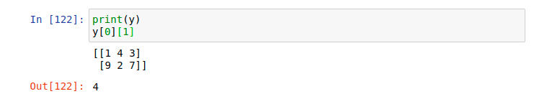
.
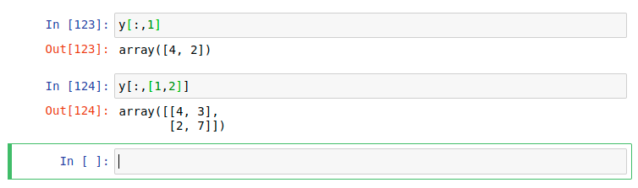
.
.

END.

